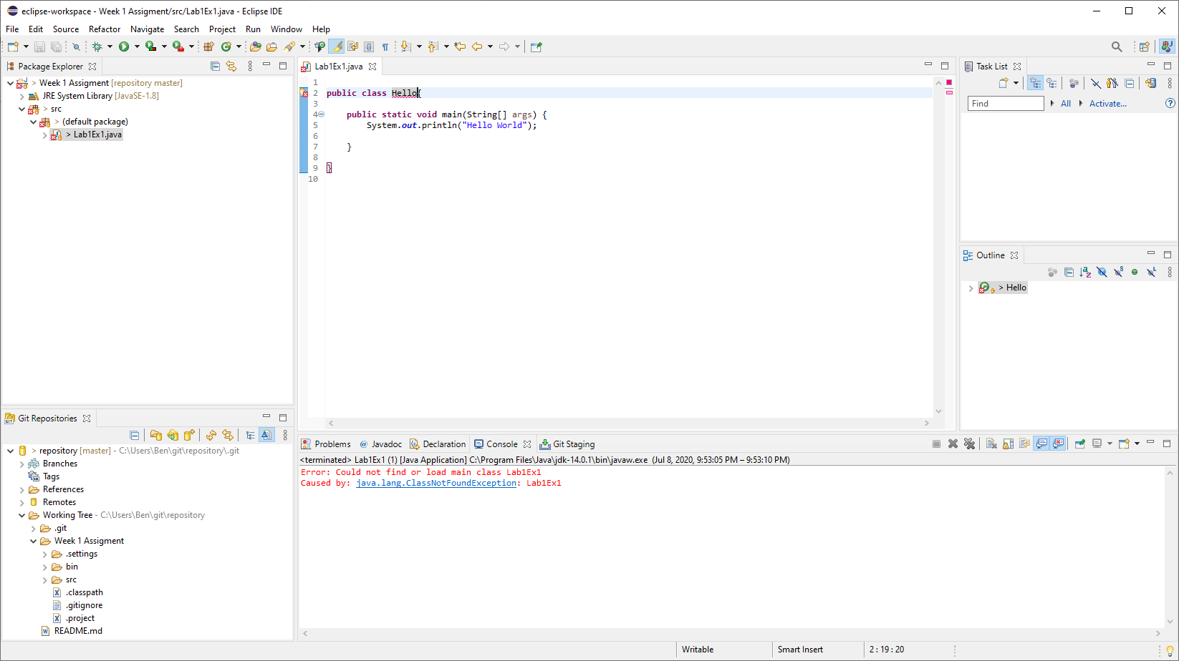

Changing public class from Lab1Ex1 to Hello results in being unable to find or load the main class. Changing the class from Hello back to Lab1Ex1 allows the program to run.

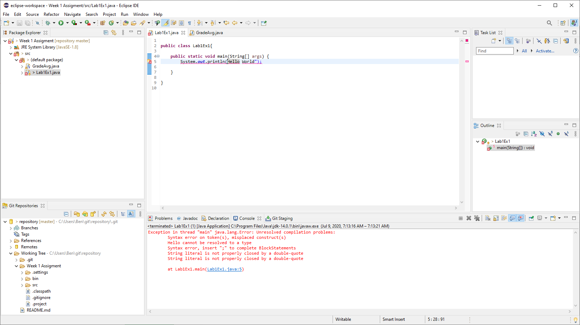

Removing the first quotation mark results in a compilation error. The string literal is not properly enclosed by quotation marks. Replacing the first quotation mark allows the program to run normally.

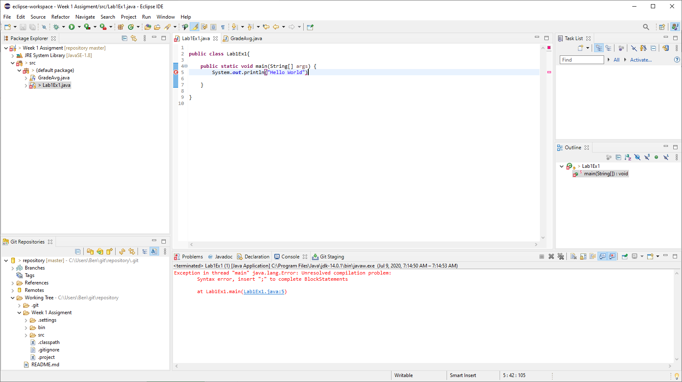

Removing the semicolon gives a syntax error and the program cannot be compiled. Adding the semicolon back allows the program to compile and run.

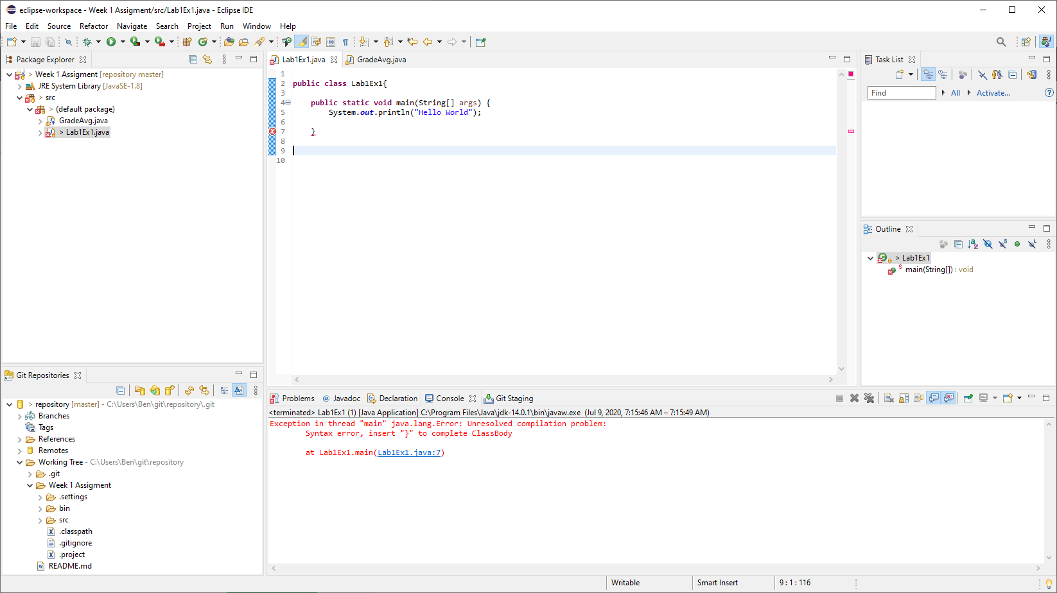

Removing the final bracket makes a syntax error. The ClassBody is incomplete without the last bracket. By replacing the bracket, the code can compile and run.